lab5

11. Create a symbolic link of /etc/passwd in /boot.
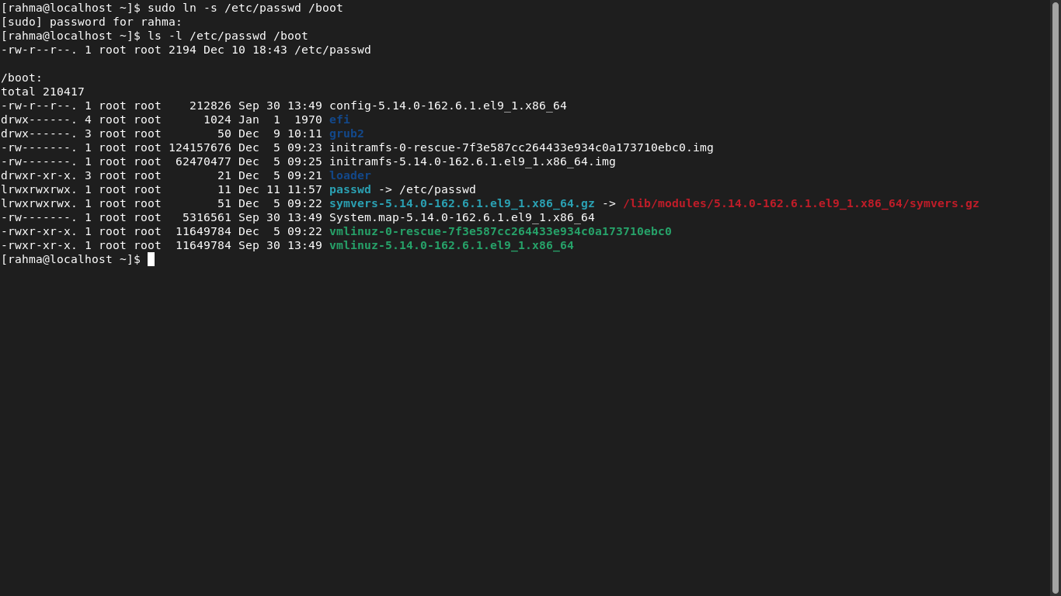

12. Create a hard link of /etc/passwd in /boot. Could you? Why?

